Summary of interclub tournament between NJTTC and Madison YMCA
On Sunday, May 26, 2019, NJTTC hosted the second friendly interclub tournament between NJTTC and Madison YMCA. Each club had a 10-man team, and the tournament started around 4:30pm . Each player could play as many or as few matches as they wished, and so a total of 74 matches were played over four hours. We all had a lot of fun and got plenty of exercise. We thank all the participants and organizers that made this event fun and successful!

Madison Y team:
Luca Amalifi, Walter Lam, Irving Adams, KC Sang, Howard Lee, Xin Tao, Jarek Chorazykiewicz, Long Peng (no show), Veng Vollavanh, & Mike Shulman.

NJTTC team:
Iuliana Radu, Chris Lehman, Davis Kam, Ed Royzman, Vincent Kam, Miller Montealegre, Harpreet Singh, Dmitriy Zhitomirskiy, Chris Shung, & Paul Gerson.

Results:
NJTTC vs Madison Y => 46 : 28

Player Stats:
Madison Y: Luca: 10W0L, Walter: 7W3L, Irving: 4W5L, KC: 4W3L, Xin: 2W4L, Veng: 1W7L, Howard: 0W6L, Jarek: 0W9L, Mike: 0W9L, Long: no show

NJTTC: Iuliana: 6W1L, Chris: 6W1L, Davis: 6W1L, Vincent: 6W3L, Miller: 6W3L, Chris S: 5W3L, Ed:
4W3L, Dmitriy: 4W4L, Harpreet: 2W4L, Paul: 1W5L

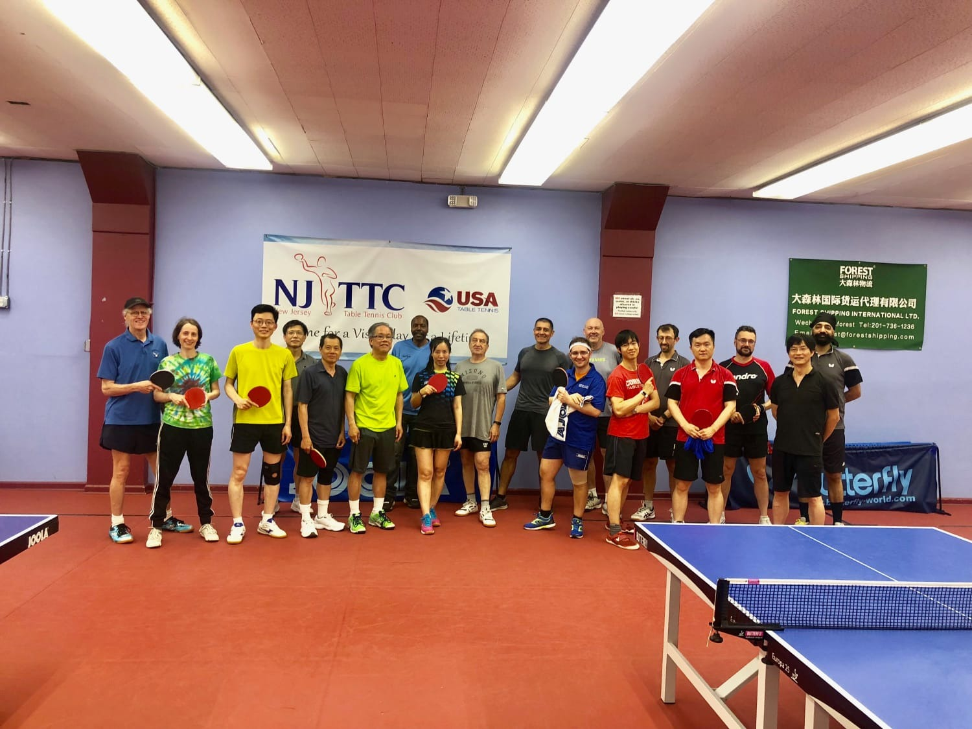

Detail results:
