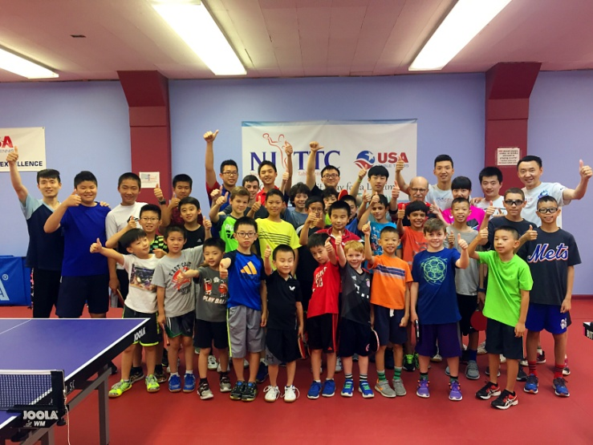**New Jersey Table Tennis Club**

**Address: 226 North Avenue West**

**Westfield, NJ 07090**

**E-mail:** [**glz116688@gmail.com**](mailto:glz116688@gmail.com)

**Web: www.njttc.org**

**Phone: 732-766-5781 (Coach Li)**

**732-822-3431(Coach Gao)**



***11/9-11/10/2017 Two Days Table Tennis Camp***

***Registration Form***

Six hours of training per day from 9:00AM-12:00PM and 2:00PM-5:00PM. The Center will be open from 8:30AM each day. Students will need to provide for their own lunch. There are many places to eat within close walking distance to the club.（Coaches can help with lunch orders）

***Professional Coaches to give you the best training.***

Fees NJTTC Member Non-member

Half day $35 $40

Day $60 $70

Name: _______________________ Age: _____ Birth Date: _______________

Parent’s Name: Phone (H): (C):______________

Street Address: ________________________City: ______________ Zip: ___________

Emergency Contact Name: ________________________ Phone: __________________

Email: _________________________________________________________________

Allergies: __________________Medications Taken: ____________________________

Signature (parent/guardian) _______________________ Date ___________